姓名：杲时雨
学号：2019116022
时间：2020.12.29
编号：1
Project: Alarm Clock
（1）问题描述：
创建一个使用标签显示当前时间的程序。允许用户选择给定时间并指定消息。当时钟到达该时间时，让它弹出一条消息提醒用户他们的消息和/或播放特定的声音文件。您需要能够获得当前时间并将其显示给用户。您还需要一种机制来保存具有特定时间和关联消息的“事件”。尝试创建一个自定义类来保存此信息。在时钟的每个滴答声中，将时间与每个保存的计划事件进行比较。如果一个匹配，则显示关联的消息。确保在给定的时间内检查多个事件，如果不需要，可能会丢弃系统中的任何旧事件（过期）。使用数字图片使时钟显示图形化。您还可以集成一个数据库，以便更轻松地跟踪多个事件。在消息中添加一个图标，并可能指定播放哪个声音文件作为警报。提醒用户事件是否“过期”以及过期的时间。

（2）设计：
UML类图：
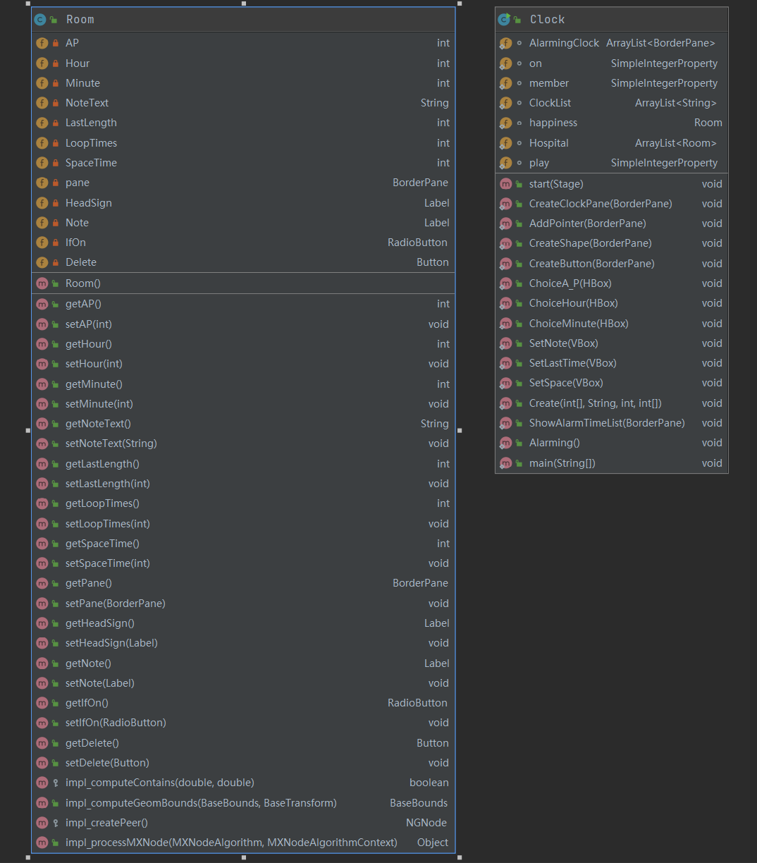
钟表界面：
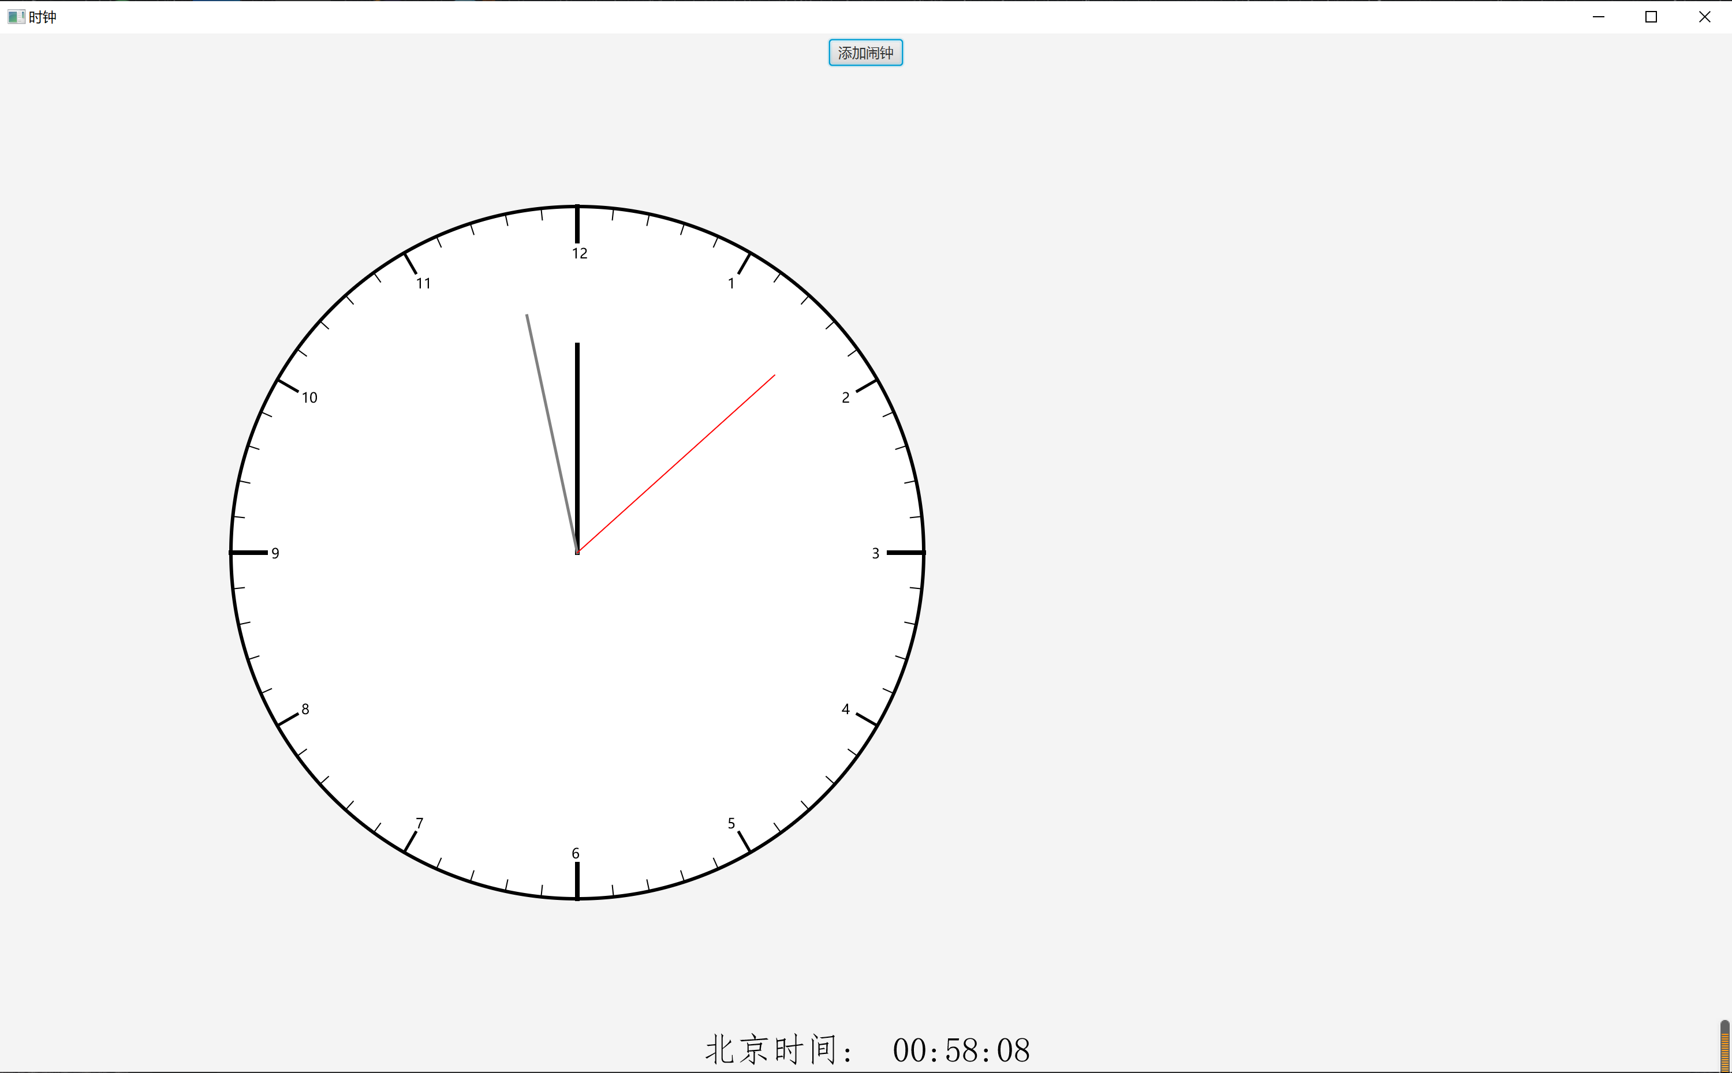

设置页面：
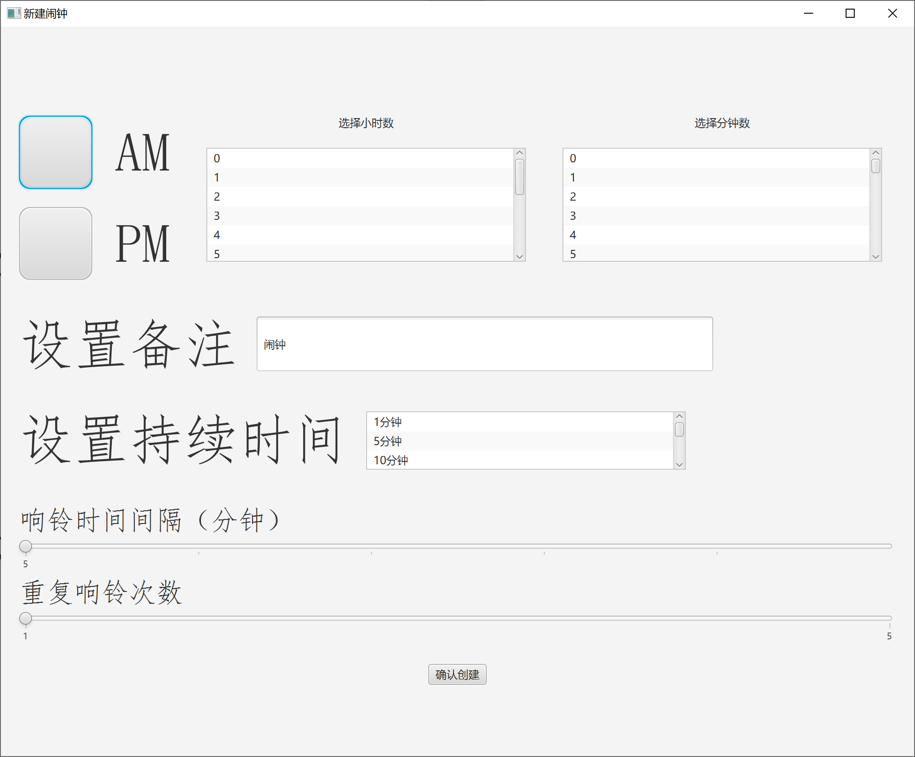

（3）代码：
Clock类代码：
import java.util.Calendar;
import javafx.scene.Scene;
import javafx.stage.Stage;
import javafx.geometry.Pos;

import java.applet.Applet;
import java.io.File;
import java.net.MalformedURLException;
import java.net.URL;
import java.util.ArrayList;
import javafx.util.Duration;
import javafx.geometry.Insets;
import javafx.scene.text.Text;
import javafx.scene.shape.Line;
import javafx.scene.media.Media;
import javafx.scene.paint.Color;
import javafx.scene.layout.HBox;
import javafx.scene.layout.VBox;
import javafx.event.ActionEvent;
import javafx.scene.shape.Circle;
import javafx.event.EventHandler;
import javafx.animation.KeyFrame;
import javafx.animation.Timeline;
import javafx.scene.control.Label;
import javafx.scene.control.Slider;
import javafx.scene.control.Button;
import javafx.scene.control.ListView;
import javafx.scene.media.MediaPlayer;
import javafx.scene.layout.BorderPane;
import javafx.application.Application;
import javafx.scene.control.TextField;
import javafx.collections.FXCollections;
import javafx.scene.control.RadioButton;
import javafx.scene.control.ToggleGroup;
import javafx.scene.control.SelectionMode;
import javafx.beans.property.SimpleIntegerProperty;

public class Clock extends Application
{
static ArrayList<BorderPane> AlarmingClock=new ArrayList<BorderPane>();
static SimpleIntegerProperty on=new SimpleIntegerProperty(0);
//on的含义是有多少闹钟是开启状态，它会被检查运行-响铃的方法监听
static SimpleIntegerProperty member=new SimpleIntegerProperty(0);
//member的含义是有多少闹钟被设定，它会被ShowAlarmTimeList方法监听

static ArrayList<String> ClockList=new ArrayList<String>();

static Room happiness=new Room();
static ArrayList<Room> Hospital=new ArrayList<Room>();

@Override
public void start(Stage primaryStage)
{
BorderPane pane=new BorderPane();
pane.setPadding(new Insets(5,5,5,5));

CreateClockPane(pane);
AddPointer(pane);

URL url=null;
File file=new File("C:\\Users\\Logic.G\\Desktop\\Kevin.wav");
try
{
url=file.toURL();
}
catch(MalformedURLException e1)
{}
java.applet.AudioClip dida;
dida=Applet.newAudioClip(url);//加载音频

EventHandler<ActionEvent> TR=e->
{
pane.getChildren().clear();
CreateClockPane(pane);
AddPointer(pane);
Alarming();
dida.play(); //播放音频

};
Timeline ANM=new Timeline( new KeyFrame(Duration.millis(1000),TR) );
ANM.setCycleCount(Timeline.INDEFINITE);
ANM.play();

Scene scene=new Scene(pane,1500,900);
primaryStage.setScene(scene);
primaryStage.setTitle("时钟");
primaryStage.show();
if(!primaryStage.isShowing())
dida.stop();
}

public static void CreateClockPane(BorderPane pane)
{
CreateShape(pane); //钟的表盘&钟点数值
CreateButton(pane); //相关按钮
ShowAlarmTimeList(pane);
}

public static void AddPointer(BorderPane pane) //钟的表针&文本显示
{
HBox HB=new HBox();
HB.setAlignment(Pos.CENTER);
HB.setSpacing(10);

Calendar time=Calendar.getInstance();
int second=time.get(Calendar.SECOND);
int minute=time.get(Calendar.MINUTE);
int hour=time.get(Calendar.HOUR);

Line HOUR=new Line();
HOUR.setStroke(Color.BLACK);
Line MINUTE=new Line();
MINUTE.setStroke(Color.GREY);
Line SECOND=new Line();
SECOND.setStroke(Color.RED);
HOUR.startXProperty().bind(pane.widthProperty().divide(3));
MINUTE.startXProperty().bind(pane.widthProperty().divide(3));
SECOND.startXProperty().bind(pane.widthProperty().divide(3));
HOUR.startYProperty().bind(pane.heightProperty().divide(2));
MINUTE.startYProperty().bind(pane.heightProperty().divide(2));
SECOND.startYProperty().bind(pane.heightProperty().divide(2));
HOUR.setStrokeWidth(4);
MINUTE.setStrokeWidth(2.5);
SECOND.setStrokeWidth(1);

HOUR.endXProperty().bind( pane.widthProperty().divide(3).add(180*Math.sin(2*Math.PI*hour/12.0) ) );
HOUR.endYProperty().bind( pane.heightProperty().divide(2).subtract(180*Math.cos(2*Math.PI*hour/12.0) ) );
MINUTE.endXProperty().bind( pane.widthProperty().divide(3).add(210*Math.sin(2*Math.PI*minute/60.0) ) );
MINUTE.endYProperty().bind( pane.heightProperty().divide(2).subtract(210*Math.cos(2*Math.PI*minute/60.0) ) );
SECOND.endXProperty().bind( pane.widthProperty().divide(3).add(230*Math.sin(2*Math.PI*second/60.0) ) );
SECOND.endYProperty().bind( pane.heightProperty().divide(2).subtract(230*Math.cos(2*Math.PI*second/60.0) ) );

pane.getChildren().add(HOUR);
pane.getChildren().add(MINUTE);
pane.getChildren().add(SECOND);

String S1=hour<10?"0":"";
String S2=minute<10?"0":"";
String S3=second<10?"0":"";
if(time.get(Calendar.AM_PM)==1)
{
hour+=12;
S1="";
}
Text NT=new Text("北京时间: "+S1+hour+":"+S2+minute+":"+S3+second);
NT.setStyle("-fx-font-family: 'FangSong';-fx-font-size: 30;");
HB.getChildren().add(NT);
pane.setBottom(HB);
}

public static void CreateShape(BorderPane pane) //钟的表盘
{
Circle clock=new Circle();
clock.centerXProperty().bind(pane.widthProperty().divide(3));
clock.centerYProperty().bind(pane.heightProperty().divide(2));
clock.setRadius(300);
clock.setFill(Color.WHITE);
clock.setStroke(Color.BLACK);
clock.setStrokeWidth(3);
pane.getChildren().add(clock);
int L=0;
double D=0;
double R=clock.getRadius();
int N=12;
for(int i=0;i<60;i++)
{

if(i%5==0)
{
if(i%15==0)
{
L=270;
D=4;
}
else
{
L=280;
D=2.5;
}
double X=pane.widthProperty().divide(3).add( (L-10)*Math.sin(2*Math.PI*i/60.0) ).doubleValue()-5;
double Y=pane.heightProperty().divide(2).subtract( (L-10)*Math.cos(2*Math.PI*i/60.0) ).doubleValue()+5;
Text number=new Text(X,Y,""+N);
pane.getChildren().add(number);
if(N==12)
N=0;
N++;
}
else
{
L=290;
D=1;
}
Line sign=new Line();
sign.startXProperty().bind(pane.widthProperty().divide(3).add( L*Math.sin(2*Math.PI*i/60.0) ) );
sign.startYProperty().bind(pane.heightProperty().divide(2).subtract( L*Math.cos(2*Math.PI*i/60.0) ) );
sign.endXProperty().bind(pane.widthProperty().divide(3).add( R*Math.sin(2*Math.PI*i/60.0) ) );
sign.endYProperty().bind(pane.heightProperty().divide(2).subtract( R*Math.cos(2*Math.PI*i/60.0) ) );
sign.setStrokeWidth(D);

pane.getChildren().add(sign);
}
}

static SimpleIntegerProperty play=new SimpleIntegerProperty(0);

public static void CreateButton(BorderPane pane) //相关按钮
{
HBox HB=new HBox();
HB.setAlignment(Pos.CENTER);

Button SetNewAlarmTime=new Button("添加闹钟");

SetNewAlarmTime.setOnMouseClicked
(
e1->
{
Hospital.add(happiness);
happiness=new Room();

Stage NewStage=new Stage();
BorderPane NewPane=new BorderPane();
HBox T_SetTime=new HBox();
VBox B_SetText=new VBox();
VBox FINALLY=new VBox();
FINALLY.setAlignment(Pos.CENTER);

ChoiceA_P(T_SetTime);
ChoiceHour(T_SetTime);
ChoiceMinute(T_SetTime);
SetNote(B_SetText);
SetLastTime(B_SetText);
SetSpace(B_SetText);

int []TimeList= {happiness.getAP(),happiness.getHour(),happiness.getMinute()}; //AM&PM，小时数，分钟数
int Space[]= {happiness.getSpaceTime(),happiness.getLoopTimes()};
Button finished=new Button("确认创建");
FINALLY.getChildren().addAll(T_SetTime,B_SetText,finished);
finished.setOnMouseClicked
(
e2->
{
Create(TimeList,happiness.getNoteText(),happiness.getLastLength(),Space); //真正的创建闹钟对象
NewStage.close();
}
);

NewPane.setCenter(FINALLY);
Scene NewScene=new Scene(NewPane,1000,800);
NewStage.setScene(NewScene);
NewStage.setTitle("新建闹钟");
NewStage.show();

member.addListener
(
ov->
{
ShowAlarmTimeList(pane);
}
);

}
);

HB.getChildren().add(SetNewAlarmTime);
pane.setTop(HB);
}

public static void ChoiceA_P(HBox HB)
{
VBox VB=new VBox();
VB.setAlignment(Pos.TOP_CENTER);
VB.setPadding(new Insets(20,20,20,20));
VB.setSpacing(20);
RadioButton AM=new RadioButton("AM");
AM.setStyle("-fx-font-family: 'FangSong';-fx-font-size: 60;");
RadioButton PM=new RadioButton("PM");
PM.setStyle("-fx-font-family: 'FangSong';-fx-font-size: 60;");
VB.getChildren().addAll(AM,PM);
ToggleGroup CAP=new ToggleGroup();
AM.setToggleGroup(CAP);
PM.setToggleGroup(CAP);
HB.getChildren().add(VB);
AM.setOnAction
(
e->
{
if(AM.isSelected())
{
happiness.setAP(0);
}

}
);
PM.setOnAction
(
e->
{
if(PM.isSelected())
{
happiness.setAP(1);
}
}
);
}

public static void ChoiceHour(HBox HB)
{
VBox VB=new VBox();
VB.setSpacing(20);
VB.setPadding(new Insets(20,20,20,20));
VB.setAlignment(Pos.TOP_CENTER);
VB.setMaxHeight(200);
String[] number=new String[12];
for(int i=0;i<12;i++)
number[i]=i+"";
ListView<String> Hour=new ListView<String>( FXCollections.observableArrayList( number ) );
Hour.getSelectionModel().setSelectionMode(SelectionMode.SINGLE);
Hour.setPrefSize(350,350);

Label sign=new Label("选择小时数");

VB.getChildren().add(sign);
VB.getChildren().add(Hour);
HB.getChildren().add(VB);

Hour.getSelectionModel().selectedItemProperty().addListener
(
ov->
{
for(Integer i:Hour.getSelectionModel().getSelectedIndices())
{
happiness.setHour(i);
}
}
);
}

public static void ChoiceMinute(HBox HB)
{
VBox VB=new VBox();
VB.setSpacing(20);
VB.setPadding(new Insets(20,20,20,20));
VB.setAlignment(Pos.TOP_CENTER);
VB.setMaxHeight(200);
String[] number=new String[60];
for(int i=0;i<60;i++)
number[i]=i+"";
ListView<String> Minute=new ListView<String>( FXCollections.observableArrayList( number ) );
Minute.getSelectionModel().setSelectionMode(SelectionMode.SINGLE);
Minute.setPrefSize(350,350);

Label sign=new Label("选择分钟数");

VB.getChildren().add(sign);
VB.getChildren().add(Minute);
HB.getChildren().add(VB);

Minute.getSelectionModel().selectedItemProperty().addListener
(
ov->
{
for(Integer i:Minute.getSelectionModel().getSelectedIndices())
{
happiness.setMinute(i);
}
}
);
}

public static void SetNote(VBox VB)
{
HBox HB=new HBox();
HB.setPadding(new Insets(20,20,20,20));
HB.setSpacing(20);
Label sign=new Label("设置备注");
sign.setStyle("-fx-font-family: 'FangSong';-fx-font-size: 60;");
HB.getChildren().add(sign);

TextField NOTE=new TextField();
NOTE.setText("闹钟");
NOTE.setPrefWidth(500);
NOTE.setPrefHeight(60);

HB.getChildren().add(NOTE);
VB.getChildren().add(HB);

happiness.setNoteText( NOTE.getText() );
}

public static void SetLastTime(VBox VB)
{
HBox HB=new HBox();
HB.setPadding(new Insets(20,20,20,20));
HB.setSpacing(20);
Label sign=new Label("设置持续时间");
sign.setStyle("-fx-font-family: 'FangSong';-fx-font-size: 60;");
HB.getChildren().add(sign);

String[] last= {"1分钟" , "5分钟" , "10分钟" , " 15分钟 " , "20分钟" , "30分钟"};
ListView<String> LastTime=new ListView<String>( FXCollections.observableArrayList( last ) );
LastTime.getSelectionModel().setSelectionMode(SelectionMode.SINGLE);
LastTime.setPrefSize(350,60);
HB.getChildren().add(LastTime);
VB.getChildren().add(HB);

LastTime.getSelectionModel().selectedItemProperty().addListener
(
ov->
{
for(int i:LastTime.getSelectionModel().getSelectedIndices())
{
switch(i)
{
case 0:happiness.setLastLength(1);break;
case 1:happiness.setLastLength(5);break;
case 2:happiness.setLastLength(10);break;
case 3:happiness.setLastLength(15);break;
case 4:happiness.setLastLength(20);break;
case 5:happiness.setLastLength(30);break;
}
}
}
);
}

public static void SetSpace(VBox VB)//Unfinished
{
VBox SS=new VBox();
SS.setSpacing(5);
SS.setPadding(new Insets(20,20,20,20));
SS.setAlignment(Pos.CENTER_LEFT);

Label space=new Label("响铃时间间隔（分钟）");
space.setStyle("-fx-font-family: 'FangSong';-fx-font-size: 30;");

Slider SPACING=new Slider(5,30,5);
SPACING.setShowTickLabels(true);
SPACING.setShowTickMarks(true);
SPACING.setMinorTickCount(4);

Label times=new Label("重复响铃次数");
times.setStyle("-fx-font-family: 'FangSong';-fx-font-size: 30;");

Slider TIMES=new Slider(1,5,1);
TIMES.setShowTickLabels(true);
TIMES.setShowTickMarks(true);
TIMES.setMinorTickCount(3);

SS.getChildren().addAll(space,SPACING,times,TIMES);
VB.getChildren().add(SS);
}

//Finally
public static void Create(int[] TimeList,String NOTE,int LastTime,int[] space)
{

happiness.getDelete().setOnAction
(
e->
{
if(AlarmingClock.size()==1)
AlarmingClock.clear();
else
AlarmingClock.remove(happiness.getPane());
ClockList.remove( (3600*(TimeList[1]+12*TimeList[0]*12)+60*TimeList[2])+"" );
member.subtract(1);

}
);
happiness.getIfOn().setOnAction
(
e->
{
if( happiness.getIfOn().isSelected()||!AlarmingClock.contains( (3600*(TimeList[1]+12*TimeList[0]*12)+60*TimeList[2])+"" ) )
ClockList.add( (3600*(TimeList[1]+12*TimeList[0]*12)+60*TimeList[2])+"" );
else
ClockList.remove( (3600*(TimeList[1]+12*TimeList[0]*12)+60*TimeList[2])+"" );
}
);

AlarmingClock.add(happiness.getPane());
member.add(1);
ClockList.add( (3600*(TimeList[1]+12*TimeList[0]*12)+60*TimeList[2])+"" );
}

//FinallyShow
public static void ShowAlarmTimeList(BorderPane pane)
{
VBox VB=new VBox();
for(int i=0;i<AlarmingClock.size();i++)
VB.getChildren().add(AlarmingClock.get(i));
pane.setRight(VB);
}

public static void Alarming()
{
Calendar time=Calendar.getInstance();
int minute=time.get(Calendar.MINUTE);
int hour=time.get(Calendar.HOUR);
int ap=time.get(Calendar.AM_PM);

URL url=null;
File file=new File("C:\\Users\\Logic.G\\Desktop\\Kevin.wav");
try
{
url=file.toURL();
}
catch(MalformedURLException e1)
{}
java.applet.AudioClip ring;
ring=Applet.newAudioClip(url);//加载音频

ClockList.sort(null);
for(int i=0;i<ClockList.size();i++)
{
if( (((ap*12+hour)*3600+60*minute)+"").equals( ClockList.get(i) ) )
{
System.out.println("闹钟已响铃");
ring.play();
/* ... */
}
}
}
public static void main(String[] args)
{
Application.launch(args);
}
}

Room类代码：
import javafx.scene.Node;
import javafx.geometry.Pos;
import javafx.geometry.Insets;
import javafx.scene.layout.VBox;
import javafx.scene.control.Label;
import javafx.scene.control.Button;
import com.sun.javafx.geom.BaseBounds;
import com.sun.javafx.sg.prism.NGNode;
import javafx.scene.layout.BorderPane;
import javafx.scene.control.RadioButton;
import com.sun.javafx.jmx.MXNodeAlgorithm;
import com.sun.javafx.jmx.MXNodeAlgorithmContext;
import com.sun.javafx.geom.transform.BaseTransform;

public class Room extends Node
{
private int AP=0;
private int Hour=0;
private int Minute=0;
private String NoteText="闹钟";
private int LastLength=0;
private int LoopTimes=0;
private int SpaceTime=0;
private BorderPane pane=new BorderPane();
private Label HeadSign=new Label();
private Label Note=new Label("闹钟");
private RadioButton IfOn=new RadioButton("开启闹钟");
private Button Delete=new Button("删除闹钟");

public Room()
{
pane.setPadding(new Insets(20,20,20,20));
pane.setMaxSize(600,200);

VBox VB1=new VBox();
VB1.setSpacing(20);
VB1.setAlignment(Pos.CENTER_LEFT);
VB1.setPadding(new Insets(20,20,20,20));

String TimeStage="";
if(AP==0)
{
if(Hour<4)
TimeStage="凌晨";
else if(Hour<7)
TimeStage="清晨";
else if(Hour<10)
TimeStage="早晨";
else
TimeStage="中午";
}
else
{
if(Hour<4)
TimeStage="中午";
else if(Hour<7)
TimeStage="下午";
else if(Hour<10)
TimeStage="黄昏";
else
TimeStage="半夜";
}
HeadSign.setText(TimeStage+" "+Hour+" : "+Minute);
HeadSign.setStyle("-fx-font-family: 'FangSong';-fx-font-size: 30;");
Note.setText(NoteText);
Note.setStyle("-fx-font-family: 'FangSong';-fx-font-size: 30;");
VB1.getChildren().addAll(HeadSign,Note);

VBox VB2=new VBox();
VB2.setPadding(new Insets(20,20,20,20));
VB2.setAlignment(Pos.CENTER);

IfOn.setPadding(new Insets(20,20,20,20));
IfOn.setSelected(true);
IfOn.setStyle("-fx-font-family: 'FangSong';-fx-font-size: 20;");
VB2.getChildren().add(IfOn);

Delete.setStyle("-fx-font-family: 'FangSong';-fx-font-size: 15;");
VB2.getChildren().add(Delete);

pane.setLeft(VB1);
pane.setRight(VB2);
}

public int getAP()
{
return AP;
}
public void setAP(int aP)
{
AP = aP;
String TimeStage="";
if(AP==0)
{
if(Hour<4)
TimeStage="凌晨";
else if(Hour<7)
TimeStage="清晨";
else if(Hour<10)
TimeStage="早晨";
else
TimeStage="中午";
}
else
{
if(Hour<4)
TimeStage="中午";
else if(Hour<7)
TimeStage="下午";
else if(Hour<10)
TimeStage="黄昏";
else
TimeStage="半夜";
}
HeadSign.setText(TimeStage+" "+Hour+" : "+Minute);
}

public int getHour()
{
return Hour;
}
public void setHour(int hour)
{
Hour = hour;
String TimeStage="";
if(AP==0)
{
if(Hour<4)
TimeStage="凌晨";
else if(Hour<7)
TimeStage="清晨";
else if(Hour<10)
TimeStage="早晨";
else
TimeStage="中午";
}
else
{
if(Hour<4)
TimeStage="中午";
else if(Hour<7)
TimeStage="下午";
else if(Hour<10)
TimeStage="黄昏";
else
TimeStage="半夜";
}
HeadSign.setText(TimeStage+" "+Hour+" : "+Minute);
}

public int getMinute()
{
return Minute;
}
public void setMinute(int minute)
{
Minute = minute;
String TimeStage="";
if(AP==0)
{
if(Hour<4)
TimeStage="凌晨";
else if(Hour<7)
TimeStage="清晨";
else if(Hour<10)
TimeStage="早晨";
else
TimeStage="中午";
}
else
{
if(Hour<4)
TimeStage="中午";
else if(Hour<7)
TimeStage="下午";
else if(Hour<10)
TimeStage="黄昏";
else
TimeStage="半夜";
}
HeadSign.setText(TimeStage+" "+Hour+" : "+Minute);
}

public String getNoteText()
{
return NoteText;
}
public void setNoteText(String noteText)
{
NoteText = noteText;
Note.setText(NoteText);
}

public int getLastLength()
{
return LastLength;
}
public void setLastLength(int lastLength)
{
LastLength = lastLength;
}

public int getLoopTimes()
{
return LoopTimes;
}
public void setLoopTimes(int loopTimes)
{
LoopTimes = loopTimes;
}

public int getSpaceTime()
{
return SpaceTime;
}
public void setSpaceTime(int spaceTime)
{
SpaceTime = spaceTime;
}

public BorderPane getPane()
{
return pane;
}
public void setPane(BorderPane pane)
{
this.pane = pane;
}

public Label getHeadSign()
{
return HeadSign;
}
public void setHeadSign(Label headSign)
{
HeadSign = headSign;
}

public Label getNote()
{
return Note;
}
public void setNote(Label note)
{
Note = note;
Note.setStyle("-fx-font-family: 'FangSong';-fx-font-size: 30;");
}

public RadioButton getIfOn()
{
return IfOn;
}
public void setIfOn(RadioButton ifOn)
{
IfOn = ifOn;
}

public Button getDelete()
{
return Delete;
}
public void setDelete(Button delete)
{
Delete = delete;
}

@Override
protected boolean impl_computeContains(double arg0, double arg1)
{
return false;
}
@Override
public BaseBounds impl_computeGeomBounds(BaseBounds arg0, BaseTransform arg1)
{
return null;
}
@Override
protected NGNode impl_createPeer()
{
return null;
}
@Override
public Object impl_processMXNode(MXNodeAlgorithm arg0, MXNodeAlgorithmContext arg1)
{
return null;
}
}

（4）运行程序的屏幕截图：
① 启动页面：
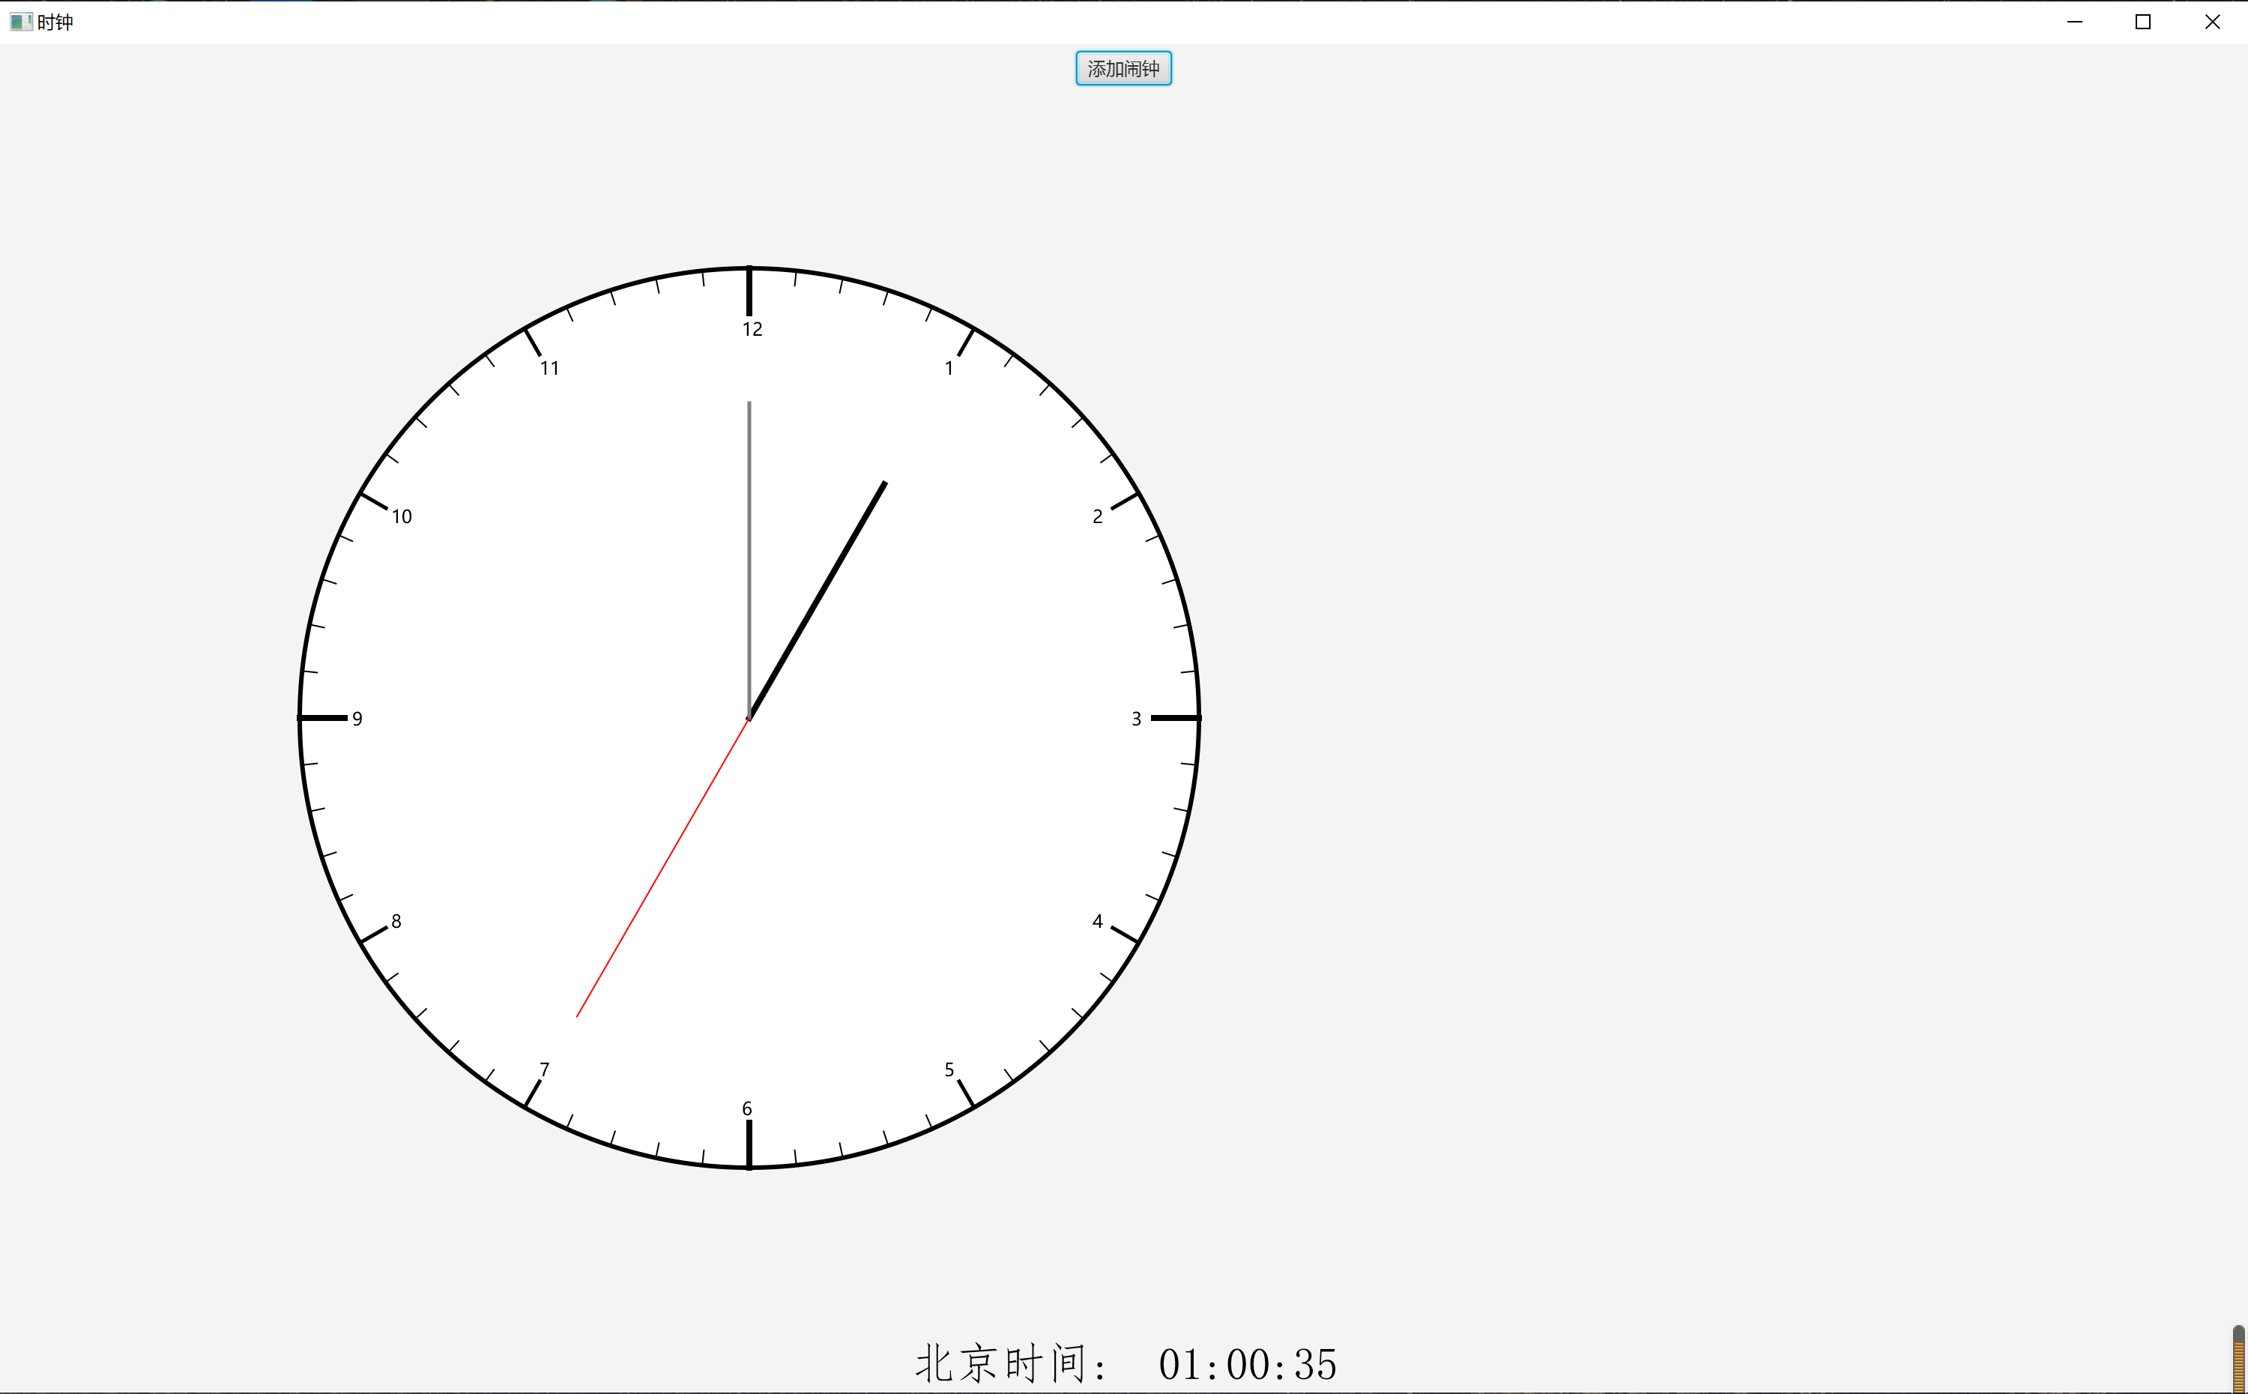

② 点击上方的添加闹钟按钮：

③ 可选择相关的设置信息，并点击确定：
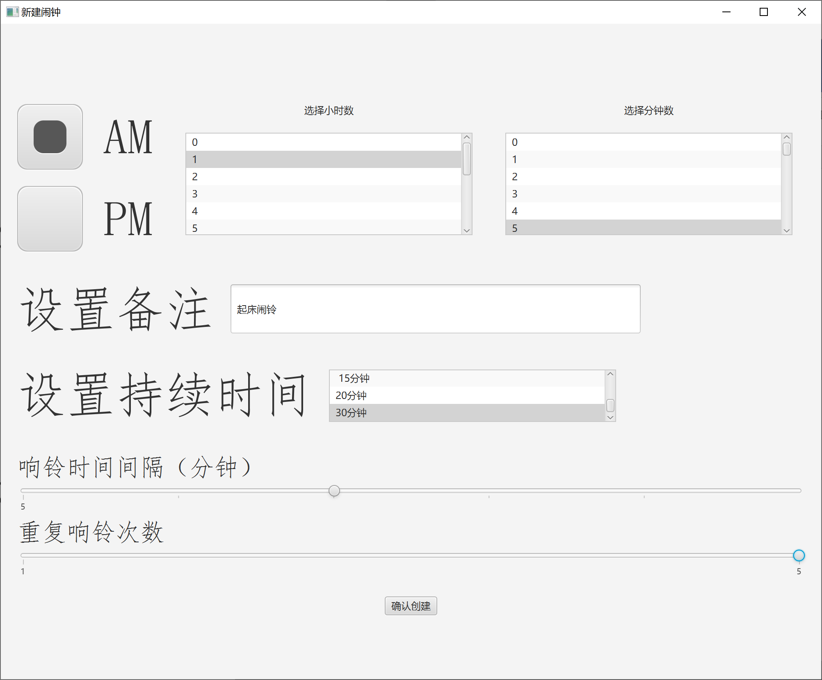
④ 添加闹钟成功，等到闹钟响铃
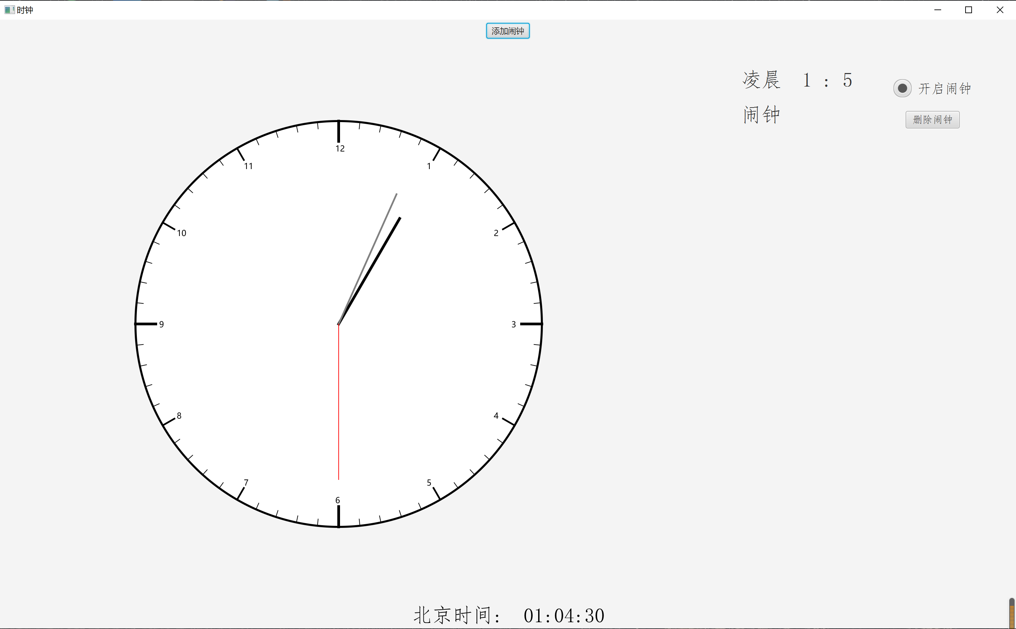

⑤ 时间到达01：05，开始响铃，点击取消，结束闹钟。

（5）自我评价：
功能：
① 本程序可用于查看时间，其钟表盘的运动是随着时间进行运动的。
② 闹钟的设定，可以在程序运行时一直进行监控，当达到设定的时间后，程序就会启动响铃模式。
③ 可设计时间范围精确到分。
④ 可以为闹铃设置备注。
⑤ 可以设置闹钟的持续时间分为1、5、10分钟。
⑥ 可以设置闹铃响铃间隔，由1分钟到5分钟。
⑦ 可以设置闹铃响铃次数。

UI界面：
① 表盘呈现为圆形，并且各项数据可随着窗体的大小改变而改变，具有可操作性。
② 钟表界面最下方提示北京时间，方便用户使用。
③ 在闹钟设置界面中，有各类时间的设定，方便操作。
④ 各类型的UI设计有序，方便查看。

稳定性：
① 程序稳定性较好，未发现明显的bug出现，性能表现较好。

